Cloud Readiness Assessment

## Delete Red Text before submitting document. The Red Text is meant to provide detailed instructions for the user on how to use and populate the template.

## Orange Text provides general information or examples and should be changed to Black Text before submitting (delete this line before submitting).

## Revision Number – The initial issue (document version) will have a base revision level of “1” followed by the next sequential number.

## Name of Solution

### Author: Name of Document Author

### Title of Document Author

# Approvals/Sign-off

Documents are reviewed and approved by a member of the Enterprise Architecture team.

# Solution Description

|  |  |
| --- | --- |
| **Solution Name** | Write the complete software application name, including any acronym. |
| **Business Owner** | Write the name of the person or organization outside of IT who owns the application. |
| **System Owner** | Write the name of the person or organization who owns the application. |
| **System Contact** | Write the name of the IT contact that is responsible for installing or maintaining the application on the Hill-Rom Infrastructure. |
| **Data Volume** | Data creation/ingestion rate |
| **Licensing Structure** | Type of software licenses and how many |
| **Hardware Sizing** | Memory, CPU’s, disk type, disk space, disk volume |
| **Operating System** | Windows/Linux |
| **Database** | Oracle, SQL Server, PostgreSQL, etc. |
| **Browser** | IE, Chrome, N/A, etc. |
| **Required Software** | Tomcat, Java, etc. |
| **Intended Use** | Please describe the specific intended use as defined by the user. |

## This assessment involves four steps. The first step is a Cloud Deployment Model questionnaire that will help determine the appropriate level of virtualization for each solution. Next, there is a Cloud Service Model questionnaire to determine the best type of cloud service for the solution identified. Next, please provide all solution dependencies. Lastly, please fill-in the events that would foreshadow an exit from a cloud solution.

# Cloud Deployment Model Questionnaire

Explanations in Appendix A

|  | **Yes** | **No** |
| --- | --- | --- |
| 1. Will the solution include sensitive data? |  |  |
| 1. Will the solution include critical data? |  |  |
| 1. Does the solution involve more than data? |  |  |
| 1. Will the solution be critical to business processes? |  |  |
| 1. Is the current infrastructure adequate for the solution needs? |  |  |
| 1. Will the performance of the solution be predictable? |  |  |
| 1. Are there any legal or compliance impediments? |  |  |
| 1. Is data ownership defined? |  |  |
| 1. Is there a jurisdiction limitation? |  |  |
| 1. Does the current SLA cover the needs of the solution? |  |  |
| 1. Will the solution be cost efficient? |  |  |
| 1. Will disaster recovery and business continuity be needed additional to what the cloud service provider can offer? |  |  |
| 1. Can the solution be upgraded cost effectively? |  |  |
| 1. Does the current SLA cover the needs of the solution? |  |  |

## Use answers to navigate the Cloud Deployment Model decision tree below:

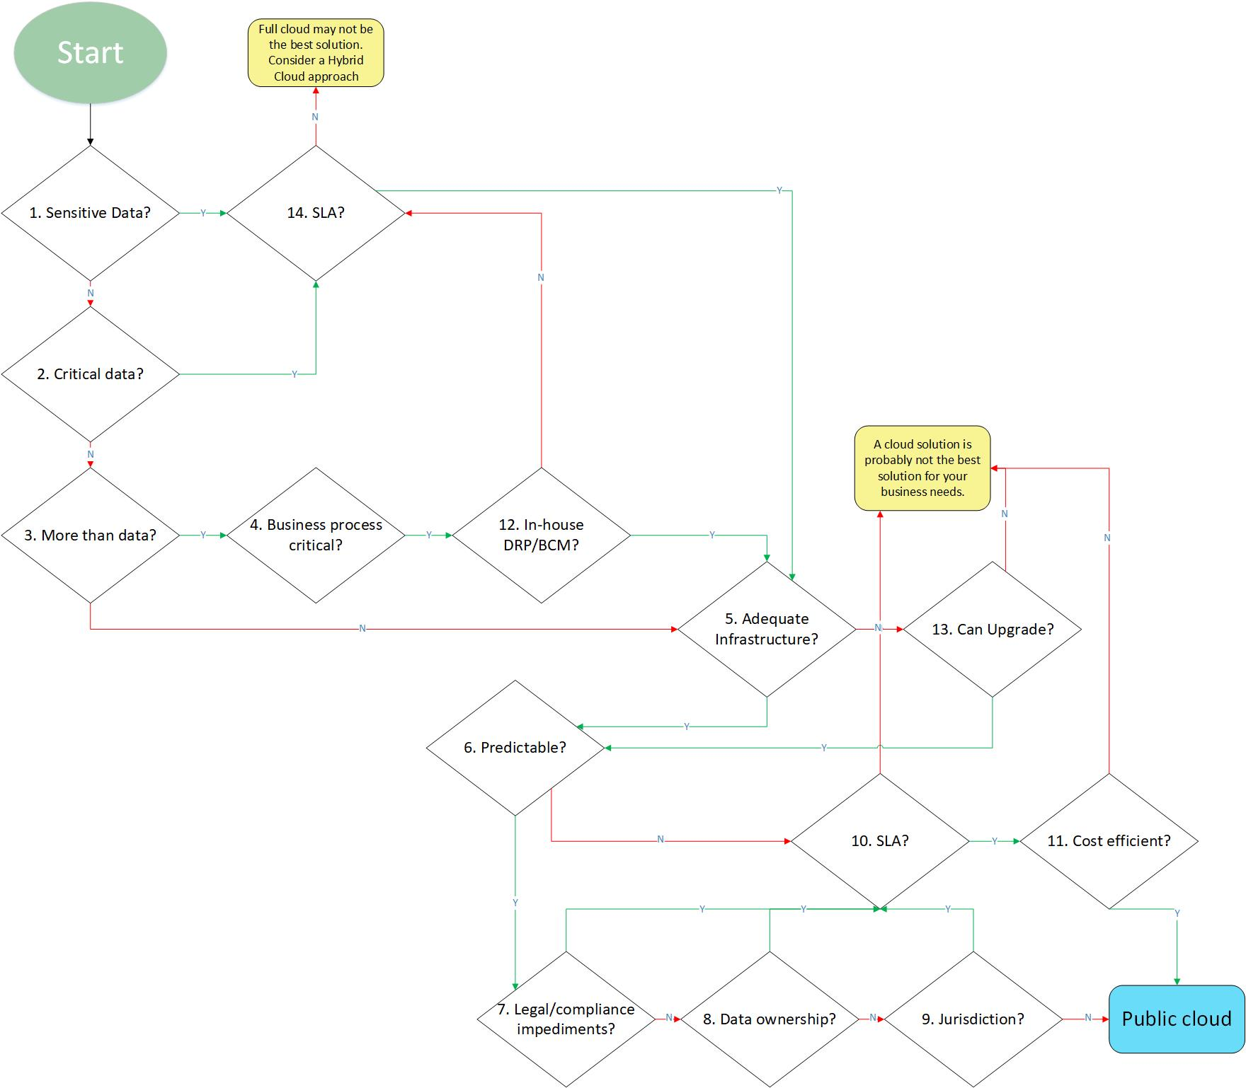

## Cloud Model Category

#### From the decision tree above, indicate which cloud category will be the best fit for this solution:

|  |  |  |
| --- | --- | --- |
| **Please select only one:** |  |  |
|  | **Public Cloud** | An offering from one CSP to many clients who share the cloud  processing power and storage capacity concurrently. Public cloud clients share applications, processing power and data storage space communally. Client data are commingled, but segregated, for example, through the use of metatags. |
|  | **Hybrid Cloud** | As organizations continue the transition made possible by enhanced virtualization, they can bridge local private clouds with other cloud offerings to create hybrid clouds, extending their resource pool beyond the systems present in local data centers. This allows an organization’s services to develop greater capacity for response to peak loads and unanticipated demands. Billing continues to develop along the utility model, allowing load to determine cost as operational expenses and internal billing for cost recovery.  A combination of two or more cloud deployment models (private or public) that remain unique entities, but are bound together by standardized or proprietary technology that enables data and application portability, e.g., cloud bursting for load balancing between clouds |
|  | **Cloud may not be the best solution** | The solution is poses too much of a risk for a cloud deployment. |

# Cloud Service Model Questionnaire

Explanations in Appendix B

|  | **Yes** | **No** |
| --- | --- | --- |
| 1. Is the business process a nonstandard solution? |  |  |
| 1. Are there interdependencies with business processes? |  |  |
| 1. Is there a difference from standard IT-based solutions? |  |  |
| 1. Is the application/hardware/OS custom? |  |  |
| 1. Is the hardware/OS custom? |  |  |
| 1. Is the hardware custom? |  |  |
| 1. Is the business driver cloud-compatible? |  |  |

## Use answers to navigate the Cloud Service Model decision tree below:

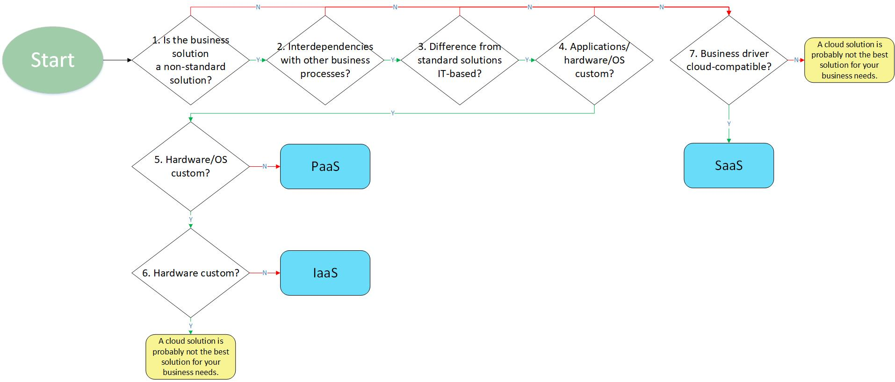

## Cloud Service Category

#### From the decision tree above, indicate which cloud service will be the best fit for this solution:

|  |  |  |
| --- | --- | --- |
| **Please select only one:** |  |  |
|  | **Infrastructure as a Service (IaaS)** | Represents cloud resources provided at the lowest level-storage, databases, network interconnections, and similar functions. This is the most flexible level of cloud service but requires the most management and planning of the consuming organization. |
|  | **Platform as a Service (PaaS)** | Represents cloud resources provided at the development level for custom application development and hosting. Consuming organizations have no concern over infrastructural decisions but may be limited by the available languages supported by their PaaS provider. |
|  | **Software as a Service (SaaS)** | Represents cloud resources provided as prebuilt applications accessible over the Internet. Consuming organizations have limited or no control over feature additions or application changes. |
|  | **Cloud may not be the best solution** | The solution is poses too much of a risk for a cloud deployment. |

# Solution Dependencies

#### Please indicate the solution dependencies below:

|  |  |  |
| --- | --- | --- |
| **Please select all that apply:** |  |  |
|  | **Technical** | **Examples:**  ■ Cloud platform service configuration including elastic scaling, resource monitoring, etc.  ■ Virtual infrastructure configuration, including VM configuration, storage types (block, object,  etc.)  ■ Network configuration, including VPN, DNS and content delivery  ■ Security configuration, including firewalls, access control lists and encryption keys  ■ Software configuration, including database (relational/NoSQL/Hadoop), middleware, etc.  ■ Software licensing (e.g., service provider licensing agreements, OS and third-party software)  ■ Integration of on-premises systems, such as private clouds, IAM, message queuing, etc.  ■ IT services management capabilities (e.g., identity, asset, change, configuration, incident and  monitoring)  ■ Nonprovider solutions (e.g., brokers, bridges, gateways and appliances) |
|  | **Business** | ■ SLAs, performance expectations  ■ Support and communication processes  ■ Terms of service/enterprise agreement  ■ Audit or compliance accreditations  ■ Customer contracts  ■ Mobile access  ■ Analytics and reporting |
|  | **Financial** | ■ Price of services  ■ Billing arrangements  ■ Provider viability  ■ Prepaid arrangements Provider's solution no longer supports customer requirements and/or better offerings with more sophisticated features exist in the market |
|  | **External Events** | ■ Data privacy requirements  ■ Any regulations that impact the application  ■ Legal jurisdictions |
|  | **Other** | ■ None of the above, please describe here: |

# Cloud Exit

#### Indicate which conditions would be intolerable and foreshadow an exit from the chosen cloud solution:

|  |  |  |
| --- | --- | --- |
| **Please select all that apply:** |  |  |
|  | **Cloud outages** | **Examples:**  ■ Provider's services less reliable than advertised in SLAs, contracts or expressed expectations (i.e., repeated or prolonged outages)  ■ Changes in service levels  ■ Lack of support |
|  | **Price Increase** | ■ Price increases  ■ Lack of remuneration for services lost |
|  | **Business Relationships** | ■ Poor business performance or indications of financial weakness  ■ Potential acquisition of either your own organization or the cloud provider  ■ Provider bankruptcy or provider exiting the market  ■ Change of terms and conditions  ■ Data, security or privacy breach  ■ Provider's solution no longer supports customer requirements and/or better offerings with more sophisticated features exist in the market  ■ Expiration of enterprise agreement or contract |
|  | **External Events** | ■ External events (legal, political, financial, etc.) that impact the viability of the cloud in general or of a specific cloud provider |
|  | **Other** | ■ None of the above, please describe here: |

#### Summary of Selections

| Deployment | Service | Dependencies | Exit Events |
| --- | --- | --- | --- |
| |  |  | | --- | --- | |  | **Public Cloud** | |  | **Hybrid Cloud** | |  | **Cloud may not be the best solution** | | |  |  | | --- | --- | |  | **IaaS** | |  | **PaaS** | |  | **SaaS** | |  | **Cloud may not be the best solution** | | |  |  | | --- | --- | |  | **Technical** | |  | **Business** | |  | **Financial** | |  | **External Events** | |  | **Other** | | |  |  | | --- | --- | |  | **Cloud outages** | |  | **Price Increase** | |  | **Business Relationships** | |  | **External Events** | |  | **Other** | |

#### Revision History

| **Rev** | **Revised By** | **Summary of Change** |
| --- | --- | --- |
| 1 | Name of Person(s) Submitting Assessment | The revision history is completed when a new assessment is completed or if there is a change/update made to the software which would require a new assessment. If this is the first revision (a new document), write in the summary of change section “Initial Release.” When an update is necessary, the description of the change includes an explanation of what section(s) were changed and the nature of the change(s). Format, punctuation and grammatical changes can be generalized. |
|  |  |  |

### Appendix A – Cloud Deployment Model question explanations

|  |  |  |
| --- | --- | --- |
| Question | Answer | Explanation |
| 1. Sensitive data? | Yes | When considering a move to a cloud infrastructure it is very important to be aware what data are to be released to the cloud. It is impossible to envision all potential risk and threats; however, data of a sensitive nature can be placed in the cloud when the necessary controls to protect them are in place and work effectively. |
| No | If data is not sensitive or if no data upload to the cloud is required, the first steps toward the cloud are taken |
| 2. Critical data? | Yes | Critical data can be: • Blueprints • Formulas • Trade secrets • Any information absolutely necessary for the enterprise to operate  Critical data can be placed in the cloud when necessary controls to protect them are in place and working effectively. It is important to note, however, that some of these controls can be expensive and complex, which may increase the cost of moving to the cloud. |
| No | Noncritical data can be easily placed in the cloud. |
| 3. More than data? | Yes | In almost all cases the decision to move to the cloud is not restricted to solely the data. Data in the cloud is often needed to run application or as part of business processes. |
| No | If the decision to move to the cloud is limited to data only, the next step is to evaluate the enterprise’s readiness for this move. |
| 4. Business process critical? | Yes | To make a sound decision, it is imperative to determine whether data and applications hosted in the cloud support critical business processes. This information will help determine the requirements that the cloud solution must satisfy. |
| No | When a business process or supporting application is not considered critical, it may be easier to move to the cloud. |
| 5. Adequate infrastructure? | Yes | A move to the cloud is a step toward reducing the enterprise’s IT infrastructure; however, proper planning is needed prior to adopting a cloud solution. Some things to consider as part of the readiness assessment include: • Connectivity to the CSP (bandwidth, redundancy) • Network security (data encryption during transfer) • Integration between cloud and non-cloud systems • User connectivity (bandwidth to the desktop or mobile devices) |
| No | If it is determined that the current enterprise infrastructure is not ready to integrate with the cloud, the next step is to determine whether the business needs are greater than the cost to upgrade (feasibility analysis). |
| 6. Predictable? | Yes | As part of the readiness assessment the enterprise must determine how business processes function and mature. This information can help anticipate capacity fluctuation (up or down) that must be part of the contract with the CSP. |
| No | When the enterprise cannot anticipate capacity fluctuations, further analysis may be needed. Flexibility and scalability are two of the cloud characteristics that make it attractive—a flexible SLA may be the solution until the enterprise has more refined requirements. |
| 7. Legal/compliance impediments? | Yes | There may be legal or compliance reasons why data or certain business functions cannot be moved to the cloud. It is important for the CSP to implement the necessary controls to ensure the enterprise’s legal and compliance continuity. The CSP must be able to provide proof of compliance as reported by a neutral audit or control body. Identification of legal or compliance limitations must be addressed during contract negotiations to stipulate the enterprise’s expectation and how they will be satisfied. |
| No | If the enterprise does not have any legal or compliance impediments, the next steps to move to the cloud can be taken. |
| 8. Data ownership? | Yes | The contract with the CSP should clearly stipulate that the enterprise is, and will remain, the data owner. It is equally important that this ownership be maintained throughout the entire data life cycle. Therefore, the contract should also outline the requirements to dispose of data in an adequate manner when the enterprise deems necessary. If data ownership cannot be properly established, the enterprise may choose to move only non-sensitive and noncritical data. |
| No | If the enterprise can clearly define data ownership during contract negotiations, the next steps to move to the cloud can be taken. |
| 9. Jurisdiction? | Yes | Even though data ownership resides with the enterprise, local and international laws often forbid the transfer or certain data to countries that have conflicting laws or regulations. Therefore, it is important for the enterprise to know the location of the CSPs data storage facilities and data processing centers to prevent legal infractions. If is advisable for the enterprise to include in the contract with the CSP the necessary clauses requiring the CSP to limit service locations to those approved by the enterprise. |
| No | If the enterprise does not have jurisdiction limitation, the cloud may be a proper solution. |
| 10, 14. SLA? | Yes | The enterprise must determine in advance the terms that will be included in the SLA keeping in mind that strict or complex SLAs could result in higher maintenance cost. Some of the terms that should be negotiated and documented in the SLA include: • Availability • Response time for additional computing resources requests • Response time for incidents • Backup policies • Data retention and disposal policies and procedures • Path management • Security controls • Recovery and continuity objectives • Controls to satisfy legal and compliance requirements |
| No | If an adequate SLA cannot be agreed on, moving to the cloud could pose an unacceptable level of risk. If the cost of the SLA is greater that the business driver, the cloud solution may not be the best solution. |
| 11. Cost efficient? | Yes | Two of the principal goals of moving to the cloud are becoming more cost effective and being able to react more quickly and inexpensively to changing situations. |
| No | Unless the business driver is greater than the cost, an expensive solution may not be the right option. |
| 12. In-house DRP/BCM? | Yes | This question may already be addressed in the SLA, but the enterprise must still be ready to consider additional DR and BC plans. A disaster occurring within the CSP is likely to cause an impact on the enterprise’s operations. For example, routes will change and entry points will be altered, causing delays in operations. If a disaster takes place within the enterprise, maintaining or reestablishing connectivity with the CSP should be a critical part of the recovery efforts. Enterprises whose data reside only on the cloud should create backups to their own premises to retain recovery and continuity capabilities even if the CSP is completely offline. |
| No | Relying solely on the DRP/BCM capabilities of the CSP can expose the enterprise to extended business outages; however, if the cost of having an in-house DRP is greater that the business driver, the enterprise may address this question in a more strict SLA. |
| 13. Can upgrade? | Yes | If it is determined that the current enterprise infrastructure is not ready to integrate with the cloud, the next step is to determine whether the business needs are greater than the cost to upgrade (feasibility analysis). |
| No | If the cost to upgrade the current infrastructure is greater that the business needs, the cloud may not be a solution yet. |

### Appendix B: Cloud Service Model question explanations

|  |  |  |
| --- | --- | --- |
| Question | Answer | Explanation |
| 1. Is the business process a nonstandard solution? | Yes | If the business process uses nonstandard solutions, then a further drilling down is needed to determine whether the business process is suitable for a cloud solution. |
| No | If a standard solution is used, then the transition to the cloud is relatively easy and the benefits of adopting a cloud solution will most likely be high. |
| 2. Interdependencies with business processes? | Yes | If there are interdependencies with different business processes, then any alteration to one of these processes could mean a change to the application implemented in the cloud. |
| No | If there are no interdependencies, then changes will not be required. The chosen cloud solution will, therefore, be independent. |
| 3. Difference from standard solutions IT-based? | Yes | While interdependency may implicate a change in the IT infrastructure, it is not always a necessity. If interdependency does implicate such a change, however, the cloud application will need to be changed. This fact will largely influence the decision for a cloud service model. Thus, it is important to outline the differences between the current solution and the standard solution provided by a CSP. |
| No | If there are no differences between the IT solutions, then the standard offerings of a CSP will adequately address the business needs. |
| 4. Application/hardware/OS custom? | Yes | Once it is established that there is indeed a gap between the business needs and the cloud service offerings, it is important to define the level on which the difference is situated. |
| No | If the differentiation is situated in the configuration of standard applications, then cloud offerings will fulfill the business needs. |
| 5. Hardware/OS custom? | Yes | After establishing that the difference is not within the application, it is important to establish whether the differentiation is found on the OS level or the physical hardware platform. The answer will alter the possibility for cloud adaptation. |
| No | If the differentiation can be done on application level, no further drill-down is needed. |
| 6. Hardware custom? | Yes | After establishing that the differentiation is located on the physical level, a cloud solution is very unlikely. CSPs are oriented toward standardization within their domain; providing custom hardware is not one of their typical offerings. While a CSP can undoubtedly provide custom hardware platforms, the high cost and the CSPs relative lack of experience in the custom platform eliminate the cloud as a viable solution. |
| No | If the differentiation can be done on the OS level, no further drill-down is needed. |
| 7. Business driver cloud-compatible? | Yes | Viable business drivers for the cloud decision include: • Reduce medium- and/or long-term total cost of ownership (TCO). • Improve cash flow by decreasing investments. • Shift from capital expenditures (CAPEX) to operating expenditures (OPEX). • Improve Quality of Service (QoS) and/or SLAs. • Gain access to functionality and/or domain expertise. |
| No | While there may be no technical constraints to adopting the cloud as a solution, it is possible that the business drivers are, in fact, not cloud-compatible. Adopting a cloud solution requires a mid- to long-term vision. Therefore, the cloud cannot be used as a solution to cut costs immediately. |